**Определение геометрических характеристик плоских сечений**

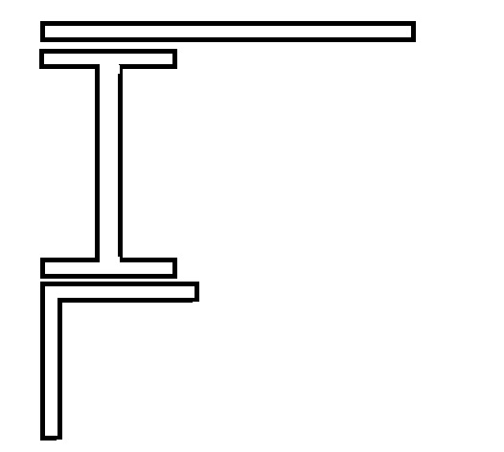

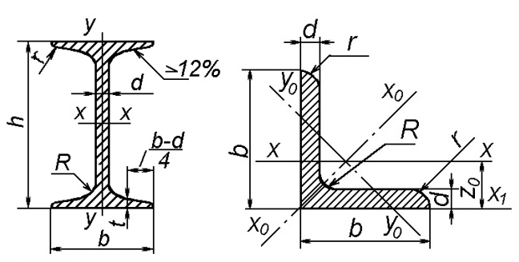

|  |  |  |
| --- | --- | --- |
| **Двутавр №22:** | **Уголок равнополочный №9** | **Лист** |
| m = 24 kg/m  h = 220 mm  b = 110 mm  S = 5.4 mm  t = 8,7 mm  A = 30.6 cm^2  **x-x**  Jx = 2550 cm^4  Wx = 232 cm^3  **y-y**  Sx = 131cm^2  Jy = 157 cm^2  Wy = 28.6 cm^2  iy = 2.27 cm | m = 8.33 kg/m  b = 90 mm  d = 6 mm  R = 10  r = 3.3  A = 10.6 cm^2  **x-x**  Jx = 82.1 cm^4  ix = 2.78 cm  **x0-x0**  Jx0max = 130 cm^2  ix0max = 3.5 cm  **y0-y0**  Jy0min = 34 cm^4  iy0min = 1.79 cm  **x1-x1**  |Jxy| = 48.1 cm^4  Z0 = 2.43 cm | b = 32 cm  h = 0.8 cm  A = 25.6 cm^2 |