C:\Users\XzoT\AppData\Local\Microsoft\Windows\Temporary Internet Files\Content.Word\yqkY6uJL068.jpg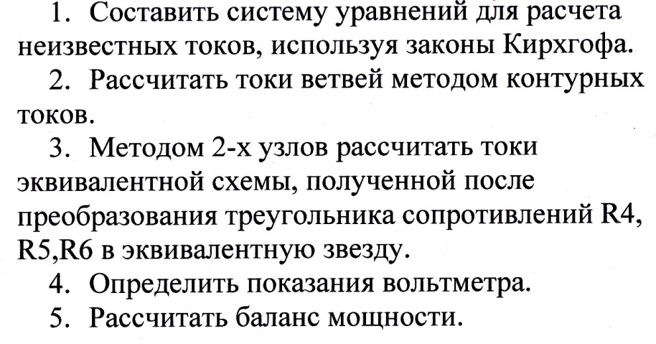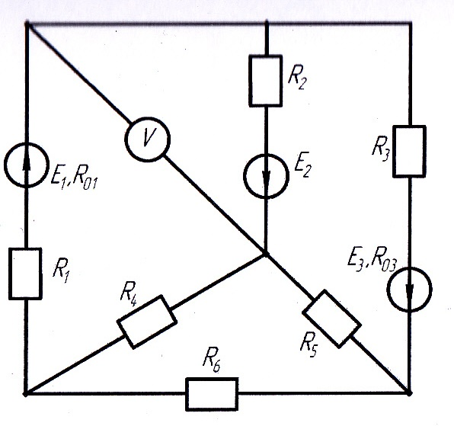C:\Users\XzoT\AppData\Local\Microsoft\Windows\Temporary Internet Files\Content.Word\yqkY6uJL068.jpgЗадание 1.

Задание 2.

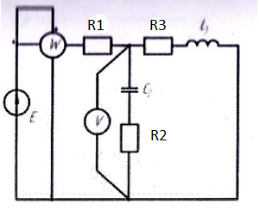C:\Users\XzoT\AppData\Local\Microsoft\Windows\Temporary Internet Files\Content.Word\IMG_0034.jpg