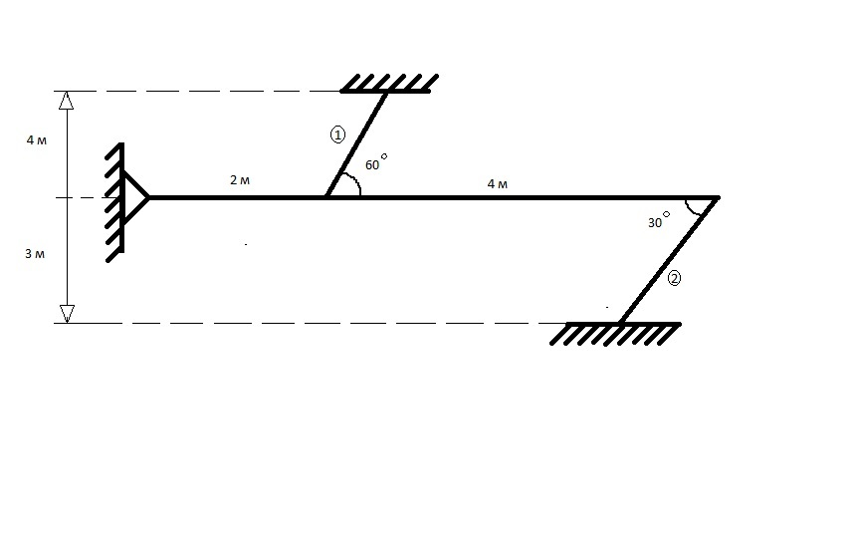

Дано:
$$\begin{aligned}{Δt}_{1,2}\text{=+}{\text{30}}^{°}C \\ α_{c}^{t}=\text{12},5⋅{\text{10}}^{−6} \\ E=2⋅{\text{10}}^{5} \text{МПа} \\ \frac{F_{1}}{F_{2}}=1 \\ \left[σ\right]=\text{160000} \text{кПа}\end{aligned}$$

Найти:
$$σ_{1}, σ_{2}=?$$

